- What is Java ?
Ans:- Java technology is both a programming language and a platform from Oracle Corporation.
- Why Java is called as “Platform” ?
ans:- A platform is basically the hardware or software environment in which a program runs. Java provides software-based platform i.e. JVM, which can run applications developed using the Java Programming Language.

- What are the features of Java ?

Ans:- Features of Java

1) Simple
Simple syntax. No pointers, no multiple inheritance with the classes which causes ambiguity error. For almost every task API (Application Programming Interface) is available; Programmer just need to know how to use that API.

2) Object Oriented
Java is strong object oriented as it does not allow features like global data, friend function which are against OOP principles.

3) Automatic Garbage Collection:
Automatic garbage collection is the process of looking at heap memory, identifying which objects are in use and which are not, and deleting the unused objects. An in use object, or a referenced object, means that some part of your program still maintains a pointer to that object. An unused object, or unreferenced object, is no longer referenced by any part of your program. So the memory used by an unreferenced object can be reclaimed.

3) Robust
Robust means strong. Java puts a lot of emphasis on early checking for possible errors, as Java compilers are able to detect many problems that would first show up during execution time in other languages.
It provides the powerful exception handling and type checking mechanism as compare to other programming languages.

4) Platform Independent
Unlike other programming languages such as C, C++ etc which are compiled into platform specific machines. Java is guaranteed to be compile-once, run-anywhere language.
On compilation Java program is compiled into bytecode. This bytecode is platform independent and can be run on any machine. Any machine with Java Runtime Environment can run Java Programs.
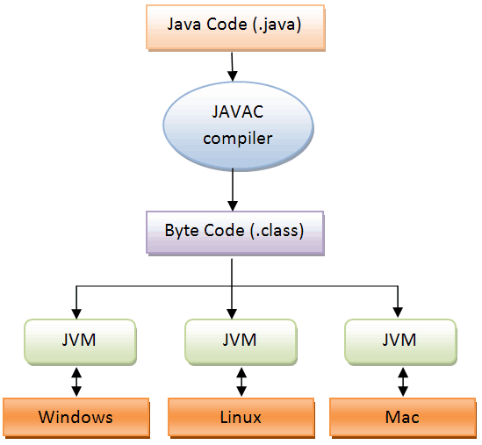

5) Secure
If a bytecode contains any virus or malicious code, JVM will not execute it. This features saves your system especially when u download java code and try to execute.

6) Multi Threading
Java multithreading feature makes it possible to write program that can do many tasks simultaneously.

7) Portable
Java Byte code can be carried to any platform.

8) Architectural Neutral
No implementation dependent features. Everything related to storage is predefined, example: size of primitive data types

8) High Performance
Java enables high performance with the use of Just-In-Time (JIT) compiler.

- How java is platform independent ?
Ans:- Java program, once compiled , can be run on any platform without recompiling.

5) is Java Pure-Object oriented Language ?
Ans:- No. Java is not because it supports Primitive datatype[^] such as int, byte, long... etc, to be used, which are not objects.
There are seven qualities to be satisfied for a programming language to be pure Object Oriented. They are:
1. Encapsulation/Data Hiding
2. Inheritance
3. Polymorphism
4. Abstraction
5. All predefined types are objects
6. All operations are performed by sending messages to objects
7. All user defined types are objects.

- Which version of java have u learned? Name some of the new features added to it.
Ans:- java8 version. Some of the new features are:

- default methods and static methods inside interface

- lambda expressions

- java fx

- method reference

- stream api

- Nashorn engine

6) What is native code?
Ans:- Native code is computer programming (code) that is compiled to run with a particular processor (such as an Intel x86-class processor) and its set of instructions.

- What is the difference bet’n JDK and JRE.
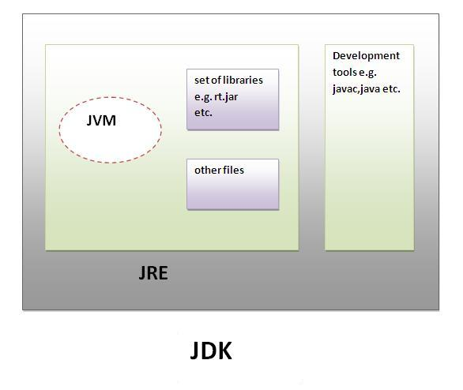
JRE is an acronym for Java Runtime Environment.It is used to provide runtime environment.It contains JVM + API ( jars and dlls)
JDK is an acronym for Java Development Kit.It physically exists.It contains JRE + development tools like compiler,debugger etc.

- What is JVM ? What it does?
Ans:- JVM (Java Virtual Machine) is an abstract machine. It is a specification that provides runtime environment in which java bytecode can be executed.

JVMs are available for various platforms (i.e.JVM is platform dependent).

It is:
- A specification where working of Java Virtual Machine is specified. But implementation provider is independent to choose the algorithm. Its implementation has been provided by Sun and other companies.
- An implementation Its implementation is known as JRE (Java Runtime Environment).
- Runtime Instance Whenever you write java command on the command prompt to run the java class, and instance of JVM is created.

The JVM performs following operation:
- Loads code
- Verifies code
- Executes code
- Provides runtime environment

- What is the lifetime of Java Virtual Machine ?
Ans:- When a Java application starts, a runtime instance of JVM is born. When the application completes, the instance dies.

- What are the main components of JVM? Explain them. Or Explain JVM Architecture.
Ans:- a) ClassLoader Subsystem b) Various Runtime Data Areas c) Execution Engine
Class loader Subsystem:

Several parts
Loading
Linking
Initializing

- Loading
BootStrap class loader
Load classes from “rt.jar” ie. All core java API classes are loaded.

Extension class loader
Loads classes from “ext” folder.
Application class loader
Loads classes from application level class path – set inside environment

Amongst all these “BootStrap class loader” will get highest priority. If “BootStrap class loader is unable to load classes then “Extension class loader” will load the the classes. If “Extension class loader” is also unable to load class file, then, “application class loader” will try to load the class file.

- Linking
Verify
BytecodeVerifier is going to check whether ur generated bytecode is proper or not. Ie. Whether it contains any virus or malicious code and whether class file format is compatible with JVM class specification. If verification fails then we will get “Verify Error”. Java program is always secure. You can execute on any machine happily because Bytecode Verifier is going to take care ,is it valid or not.

Prepare
For static variables memory will be allocated and assigned with the default values. ( not the values u have initialized with)
Resolve
All symbolic references are replaced with original references from “Method Area”. Suppose u have references to other classes, these are changed from symbolic to the actual reference
- Initialization
Static variables are assigned with the values u have initialized. Static blocks are executed in the textual order.
After Initialization only “class loading” completed successfully by “Class Loader SubSystem”.

ClassNotFoundException :- happens when class loader fails to find the bytecodes correspond to a class we mention.
ClassDefNotFoundException:- happens during a “Resolve” phase. E.g if we say
Java X
Now X will be loaded, verified , prepared. Next step is resolve. Suppose class X contains reference of class Y, resolve phase will try to find out Y.class. if class Y can not be found exception will be thrown “ClassDefNotFoundException” for X which wraps “ClassNotFoundException” for Y.

Consider following example:

public class X
{
Y ref;
public static void main(String args[])
{
X ob=new X();
ob.ref=new Y();
}
}
class Y
{
}

After compiling X.java we will get two .class files
X.class and Y.class
if we delete “Y.class” and execute application by saying
java X
we will get following exception:

Exception in thread "main" java.lang.NoClassDefFoundError: Y
at X.main(X.java:7)
Caused by: java.lang.ClassNotFoundException: Y

when u say
java Sample.class, Sample.class is an input to “ClassLoaderSubsytem”.
In short, ClassLoaderSubsytem is responsible to load our classes. In order to load the classes , some memory is required.
are various Runtime DataAreas present inside JVM.
- Method area:- will consists of following things:
class bytecode
class loader who loads the class information
reference to class Class
static variables
various literals (String,Integer,float etc)

Type Information
For each type it loads, a Java virtual machine must store the following kinds of information in the method area:
• The fully qualified name of the type
• The fully qualified name of the type's direct superclass (unless the type is an interface or class java.lang.Object, neither of which have a superclass)
• Whether or not the type is a class or an interface
• The type's modifiers ( some subset of` public, abstract, final)
• An ordered list of the fully qualified names of any direct superinterfaces

Method Information
For each method declared in the type, the following information must be stored in the method area. As with fields, the order in which the methods are declared by the class or interface must be recorded as well as the data. Here's the list:
• The method's name
• The method's return type (or void)
• The number and types (in order) of the method's parameters
• The method's modifiers (some subset of public, private, protected, static, final, synchronized, native, abstract)

method tables

A Java virtual machine can always determine the amount of memory required to represent an object by looking into the class data stored in the method area.

Since Java8, there is no “Method Area” , Now it is called as “metaspace”.
- Heap area:- objects and corresponding instance variables will be stored in heap area.

Method area and Heap area are per JVM.

- Stack area:- for every thread a separate runtime stack will be created. Each entry (method name) in the stack is called as “Stack frame”. For every thread, one runtime stack is there.
So if inside JVM 10 threads are running, 10 stacks are there.
The data which is stored inside “Stack Memory” is always a “Thread-Safe”.
It is because that data is available only for that thread not for other thread and vice-versa.
In case of recursive function if u forget to put a condition it goes into infinite loop. That is it will go on creating stack frame over stack frame over stack frame………….. That means u will go out of space in stack area memory and u will get “java.lang.StackOverflowError”

- PC register:- Program Counter Register
Every thread has got a different PC register which stores pointer to next line to be executed by JVM.
i.e. to hold address of next executing instruction.
Suppose u r running three threads T1,T2 and T3.
In this case there will be 3 program counters each for T1, T2 and T3.
- Native method stack:- if threads are invoking any native method, then for every thread a different stack will be created inside native method stack.

PC registers, Stack and Native Method Stack are per thread. So Thread1 can’t see what is there in stack frame created for Thread2 and vice-versa. That means whatever happens in method execution generally is thread-safe.
At the same time “Method Area or metaspace(in java8) “ and “heap area” are not per thread. These are created per JVM.

Execution engine:-
execution area will communicate with “Memory areas”.
i.e. once a data area is loaded which is an instruction to be executed, i.e. current instruction to be executed is ready ( using PC register) what happens is that “Java Interpreter” interprets the current instruction that is there in the bytecode and executes it.
Execution Engine has 4 components
- Interpreter (ii) JIT Compiler (iii) HotSpot profiler (iv) GC
Interpreter takes bytecode instruction, looks at it finds out what native operation to be done and executes that native operation. That is done by using “native interface” which interfaces the native libraries which are present in the JVM. If u look at the JRE bin folder, and if u r on windows u will see lot of dll files. So those are the platform specific native libraries used by the Execution Engine. If u r on unix system or linux system u will see “.so” files inside JRE bin folder which is the native library.
They allow lot of optimizations in Execution Engine so java is fast today. E.g JIT Just in time compiler is, what it does if we have certain instructions which are executed all the time again and again those will not be interpreted again and again. Instead what happens is the JIT compiler will on the fly compiles these set of instructions and keeps the target machine code ready for execution. So there is no more interpretation involved here. Its only machine code execution when u know there are so called “HotSpots” that are repeating in the application so, that what the HotSpot profiler does it keeps an eye on bytecodes which are running and grabs lot of different statistics that are useful in various formats. So that is the role of HotSpot profiler. e.g. it helps JIT Compiler to compile frequently used bytecode instructions.
Inside Execution engine two main imp. Parts are there:
- Interpreter
Read , interpret and execute java bytecode line by line.
- JIT compiler

There are other components also inside “Execution Engine”
- Garbage Collector
- Security manager

So “Execution Engine” is a central component of JVM just like our CPU or just like our “Processor”.
Execution Engine is responsible to run our program.
Interpreter is responsible to execute our program line by line. With Interpreter we face one problem. Suppose one method we call multiple times, every time interpretation must be required. Instead of that if it is a repetitive required method, better to generate machine code directly only once, next time without interpreting directly we can execute. JIT compiler is responsible to that. I.e. It is used to enhance the execution performance.
So JIT compiler is useful only in case of repeatedly invoked methods and not for every method.

When JIT compiler will come into picture?
If a method is repeatedly invoked methods.
Who is going to take care whether it is repeatedly required method or Hotspot method ?
Hotspot Profiler is responsible to identify whether method is repeatedly required ( i.e. it is HotSpot)

Sometimes while executing java programs my execution engine may require native method library that’s why we have “Native Method Libraries “ inside JRE.
Who is responsible to provide “Native Method Libraries” information?
Java Native Interface [ JNI ]
So Execution Engine will communicate with “JNI”
JNI will provide information about “Native Method Libraries” to Execution Engine.

- What is the job done by classloader ?
Ans:- classloader loads the java class. In java , classes are loaded on demand basis i.e. only when u use the class for the first time in ur application, class will be loaded.

- Explain the hierarchy of classloaders in java.
Ans:- There are 3 types of class loaders in java
- BootStrap Class Loader or Premordial Class Loader
- Extension Class Loader
- System Class Loader
BootStrap or Premordial class loader :-
BootStrap class loader loads those classes which are essential for JVM to function properly. BootStrap class loader is responsible for loading all core java classes for instance java.lang.* ,java.io.* etc. BootStrap class loader finds these necessary classes from “jdk/jre/lib/rt.jar” .
Extension class loader :-
Extensions Classloader is the immediate child of Bootstrap classloader. This classloader loads the classes in lib\ext directory of the JRE.
System class loader :-
System-Classpath classloader is the immediate child of Extensions classloader. It loads the classes and jars specified by the CLASSPATH environment variable, java.class.path system property, -cp or -classpath command line settings. If any of the jars specified in one of the above manner have a MANIFEST.MF file with a Class-Path attribute, the jars specified by the Class-Path attribute are also loaded. This class loader is also used to load an application’s entry point class that is the “static void main()” method in a class.

- What is the role played by Bytecode Verifier ?
Ans:- Bytecode Verifier performs verification of bytecodes. When a class loader presents the bytecodes of a newly loaded Java platform class to the virtual machine, these bytecodes are first inspected by a verifier. The verifier checks that the instructions cannot perform actions that are obviously damaging. All classes except for system classes are verified.

- What are the memory areas allocated by JVM ?
Ans:-
a) Class(Method) Area:
Class(Method) Area stores per-class structures such as the runtime constant pool, field and method data, the code for methods.
b) Heap:
It is the runtime data area in which objects are allocated.
c) Stack:
Java Stack stores frames. It holds local variables and partial results, and plays a part in method invocation and return.
Each thread has a private JVM stack, created at the same time as thread.
A new frame is created each time a method is invoked. A frame is destroyed when its method invocation completes.
d) Program Counter Register:
PC (program counter) register. It contains the address of the Java virtual machine instruction currently being executed.
e) Native Method Stack:
It contains all the native methods used in the application.

- What is the difference between Java compiler ( javac ) and JIT ?
Ans:- javac converts source code into the bytecode whereas JIT converts bytecode into native code.
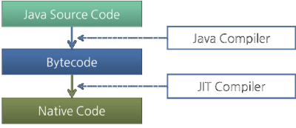

- Is JRE different for different Platforms ?
Ans:- yes

- Difference bet’n C++ and java in terms of object creation.
Ans:- in C++ object can be created on stack as well as on heap (because java has given importance to late binding from the very beginning)

- What is garbage collection ?
Ans:- Automatic garbage collection is the process of looking at heap memory, identifying which objects are in use and which are not, and deleting the unused objects. An in use object, or a referenced object, means that some part of your program still maintains a pointer to that object. An unused object, or unreferenced object, is no longer referenced by any part of your program. So the memory used by an unreferenced object can be reclaimed.

- Can we force garbage collection programmatically ?
Ans:- no, we can at the most request for Garbage Collection using “System.gc()” or “Runtime.gc()”

- What is an alternative for finalized method?
Ans:- It is not recommended to rely on finalize method because of its non-guaranteed behavior but then what is alternative of releasing resource, performing cleanup because there is no destructor in Java? Having a method like close() or destroy() make much sense for releasing resources held by classes. In fact JDK library follows this. E.g various inputstream and outputstream implementations are having “close()” method to release the resources. in fact it’s one of the best practice to call close method from finally block in java. Only problem with this approach is its not automatic, client has to do the cleanup and if client forgot to do cleanup there are chances of resources getting leaked, which again suggest us that we could probably give another chance to finalize method.
- What is the difference between System.gc() and Runtime.getRuntime().gc() ?
Ans:- Both are same. System.gc() is effectively equivalent to Runtime.gc(). System.gc()internally calls Runtime.gc().
The only difference is System.gc() is a class method where as Runtime.gc() is an instance method. So, System.gc() is more convenient.
if you look at System class source code, it has got following method:
public static void gc()
{
Runtime.getRuntime().gc();
}

- When do u get NullPointerException ?
Ans:- when reference variable containing null, used to invoke member, we get NullPointerException.

- What is the signature of main function in java ?
Ans:- public static void main(String args[]) or public static void main(String …args)

- Who invokes main() function ?
Ans:- JVM invokes main() function.

- Can we define more than one public class in a java source code ? what is the rule of public class and file name . ?
Ans:- no we can’t define more than one public class in one source file. Name of the public class and the file name must match.

- Difference bet’n path and classpath.
Ans:- path is used for “exe”,”dll” and “bat” files
Classpath is used for “jar” files.

- What is the rule for local member in java.
Ans:- local member must be initialized before use.

- What is .class file known as ?
Ans:- java bytecode

- How java is strong object oriented ?
Ans:- java does not allow global members, friend function. Everything (variables as well as methods) must be defined inside the class.

- What is finalized() method ?
Ans:- finalize method in java is called before Garbage collector reclaim the Object. It’s last chance for any object to perform cleanup activity i.e. releasing any system resources held, closing connection if open etc. Main issue with finalize method in java is its not guaranteed by JLS that it will be called by Garbage collector or exactly when it will be called, for example an object may wait indefinitely after becoming eligible for garbage collection and before its finalize() method gets called. Similarly even after finalize gets called it’s not guaranteed it will be immediately collected. Because of above reasons it make no sense to use finalize method for releasing critical resources or performing time critical activity inside finalize. It may work in development in one JVM but may not work in other JVM.
- Why there is no sizeof operator in java ?
Ans:- because size of all the java datatypes is identical across all platforms.

- What kinds of programs u can develop using Java ?
There are mainly 5 type of applications that can be created using java:
a) Standalone Application
It is also known as desktop application or window-based application. An application that contain “main” function as an entry point.
b) Applet
It is a java program which can run on java-enabled web browser
c) Web Application
An application that runs on the server side and creates dynamic page, is called web application. Currently, servlet, jsp, struts, jsf etc. technologies are used for creating web applications in java.
d) Enterprise Application
An application that is distributed in nature, such as banking applications etc. It has the advantage of high level security, load balancing and clustering. In java, EJB is used for creating enterprise applications.
e) Mobile Application
An application that is created for mobile devices. Currently Android and Java ME are used for creating mobile applications.

- Difference bet’n C++ pointer and Java reference.
Ans:- similarity bet’n two is both of them store the address of heap based object. Difference is c++ pointer can be incremented, decremented and also can be dereferenced. None of these operations u can invoke on java reference variable.
- U have reference type as a member of class. What is the default value it gets ?
Ans:- null

- What are the expressions allowed in switch block of java ?
Ans:- byte,short,int,char and String ( jdk 1.7 onwards)

- In a java source code there are 3 classes define e.g class A{} class B{} and class C{}. When u compile the source code how many .class files u get and what are their names ?
Ans:- A.class, B.classs, C.class

- What is java’s old name ?
Ans:- oak

- What are the technologies come under “Distributed Object System “ ?
Ans:- RMI, CORBA and EJB

- What do u mean by Java Enabled Browser, Web Server and Application Server ?
Ans:- Java-Enabled means having “JRE” inside it.

- What is “this” ? what is its importance ?
Ans:- this is a reference to the current object or invoking object. With the help of “this” reference member function comes to know about the invoking object. Actually when u invoke any member function, compiler implicitly passes the “this” reference to the method being invoked.

- What is UnsupportedClassVersion error ?
Ans:- when a upper-version class file is executed in the lower-version JVM, (e.g. javac belongs to 8 and JRE belongs to 1.7 )
java.lang.UnsupportedClassVersionError occurs.

- What is Unicode Character Set in Java ?
Ans:- Since Java is designed to support Internationalization ( I18N ),it makes sense that it would use Unicode to represent characters. Unicode defines a fully international character set that can represent all of the characters found in all human languages. It is a unification of dozens of character sets such as Latin, Greek, Arabic and many more. For this purpose, it requires 16 bits. Thus char in java is 16 bit type. The range of char is 0 to 65535. There are no negative chars.

- Explain Java Execution Flow.
Ans:- Virtual Machine Start-Up

A Java virtual machine starts execution by invoking the method main of some specified class, passing it a single argument, which is an array of strings if provided else an empty array.

For example:
java Test

will typically start a Java virtual machine by invoking method main of class Test .

Load the Class Test

Link Test: Verify, Prepare, (Optionally) Resolve
Linking involves verification, preparation and (optionally) resolution.

Verification checks that the loaded representation of Test is well-formed, with a proper symbol table. Verification also checks that the code that implements Test obeys the semantic requirements of the Java programming language and the Java virtual machine. If a problem is detected during verification, then an error is thrown.

Preparation involves allocation of static storage and any data structures that are used internally by the virtual machine, such as method tables.

Resolution is the process of checking symbolic references from Test to other classes and interfaces, by loading the other classes and interfaces that are mentioned and checking that the references are correct.
Resolution can be either “lazy (in case of non-static references)” or “early (in case of static references)”.

Initialize Test: Execute Initializers
Initialization consists of execution of any class variable initializers and static initializers of the class Test, in textual order. But before Test can be initialized, its direct superclass must be initialized, as well as the direct superclass of its direct superclass, and so on, recursively. In the simplest case, Test has Object as its implicit direct superclass; if class Object has not yet been initialized, then it must be initialized before Test is initialized. Class Object has no superclass, so the recursion terminates here.
If class Test has another class Super as its superclass, then Super must be initialized before Test. This requires loading, verifying, and preparing Super if this has not already been done and, depending on the implementation, may also involve resolving the symbolic references from Super and so on, recursively.
Initialization may thus cause loading, linking, and initialization errors, including such errors involving other types.

Invoke Test.main
Finally, after completion of the initialization for class Test (during which other consequential loading, linking, and initializing may have occurred), the method main of Test is invoked.

The method main must be declared public, static, and void. It must accept a single argument that is an array of strings. This method can be declared as either public static void main(String[] args)
Or public static void main(String... args)

Loading of Classes and Interfaces which are referenced from main() function………

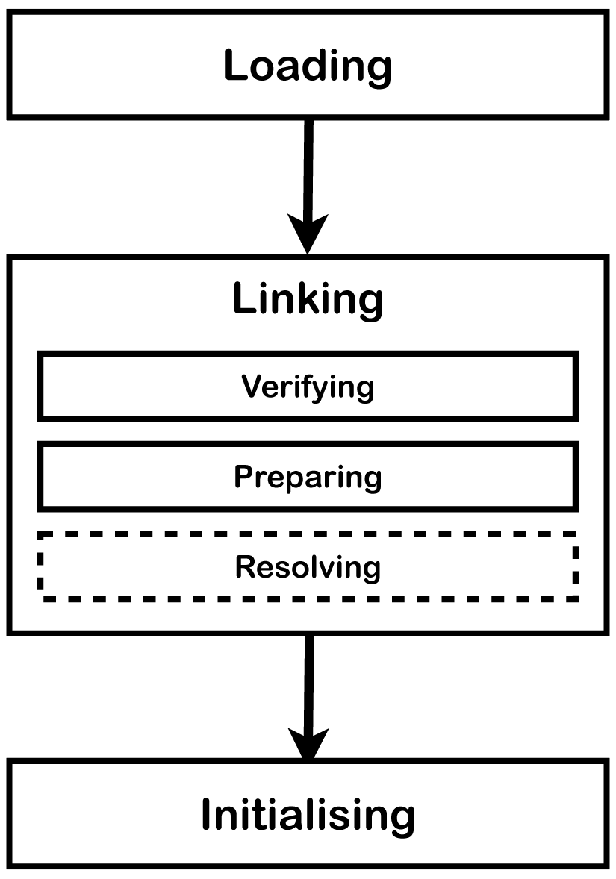

- What is the difference bet’n Lazy and Eager Resolution ?
Ans:- e.g. suppose Car class has Engine as a member.
Here if Car has Engine as static member, Engine will be resolved as soon as Car is loaded ( Eager ). On the other hand if Car has Engine as non-static member, Engine will be resolved only after you instantiate the Car (Lazy).

